Additional file 2

Model parameters
Table S1 and Table S2 show the kinetic parameters and the total concentrations for transcription factor and cofactor concentrations, respectively. Other parameters are also shown in Table S3.

Table S1. Comprehensive list of the kinetic parameters.
Reaction name | Parameter | Value | Reference
PTS1 | 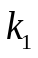 | 116 [gDCW/gProt.s] | Kotte et al. 2010
 | 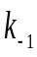 | 46.3 [gDCW/gProt.s] | Kotte et al. 2010
PTS4 | 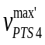 | 4.38 [μmol/gDCW.s] | *¹
 | 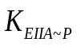 | 8.5E-3 [gProt/gDCW] | Kotte et al. 2010
 | 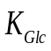 | 1.2E-3 [g/l] | Kotte et al. 2010
NPTS | 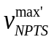 | 0.167 [μmol/gDCW.s] | *¹
 | 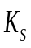 | 1.0E-2 [μmol/gDCW] | Bettenbrock et al. 2006
 | 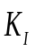 | 5.0E-6 [μmol/gDCW] | Bettenbrock et al. 2006
Glk | 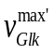 | 5.556 [μmol/gDCW.s] | *¹
 |  | 16.0 [μmol/gDCW] | Bettenbrock et al. 2006
 |  | 0.1 [μmol/gDCW] | Bettenbrock et al. 2006
Pfk | 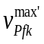 | 92.511 [μmol/gDCW.s] | *¹
 | 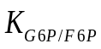 | 2.2E-2 [μmol/gDCW] | Kotte et al. 2010
 | 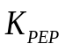 | 0.138 [μmol/gDCW] | Kotte et al. 2010
 |  | 9.5E+7 | Kotte et al. 2010
 |  | 4 | Kotte et al. 2010
Fba | 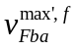 | 10.195 [μmol/gDCW.s] | *¹
 | 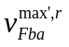 | 10.195 [μmol/gDCW.s] | *¹
 | 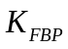 | 5.92 [μmol/gDCW] | Kotte et al. 2010
 | 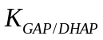 | 16.6 [μmol/gDCW] | Kotte et al. 2010
L_Emp | 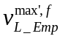 | 10.195 [μmol/gDCW.s] | *¹
 | 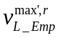 | 10.195 [μmol/gDCW.s] | *¹
 |  | 4.76 [μmol/gDCW] | Kotte et al. 2010
 | 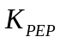 | 1.11 [μmol/gDCW] | Kotte et al. 2010
Pyk | 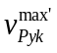 | 49.502 [μmol/gDCW.s] | *¹
 |  | 5.0 [μmol/gDCW] | Kotte et al. 2010
 |  | 0.413 [μmol/gDCW] | Kotte et al. 2010
 |  | 1.0E+5 | Kotte et al. 2010
 |  | 4 | Kotte et al. 2010
G6PDH | 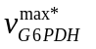 | 2.447 [μmol/gDCW.s] | *¹
 | 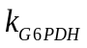 | 1.220E+4 [s] | Yao et al., 2011
 | 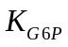 | 25.532 [μmol/gDCW] ^{*2} | Chassagnole et al. 2002
 | 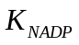 | 0.044 [μmol/gDCW] ^{*2} | Chassagnole et al. 2002
 | 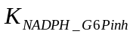 | 11.401 [μmol/gDCW] ^{*2} | Chassagnole et al. 2002
 | 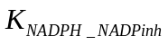 | 0.018 [μmol/gDCW] ^{*2} | Chassagnole et al. 2002
PGDH | 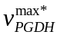 | 28.781 [μmol/gDCW.s] | *¹
 | 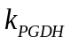 | 1.004E+4 [s] | Yao et al., 2011
 | 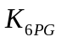 | 66.489 [μmol/gDCW] ^{*2} | Chassagnole et al. 2002
 |  | 0.090 [μmol/gDCW] ^{*2} | Chassagnole et al. 2002
 | 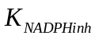 | 0.025 [μmol/gDCW] ^{*2} | Chassagnole et al. 2002
 | 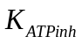 | 368.794 [μmol/gDCW] ^{*2} | Chassagnole et al. 2002
Rpe | 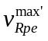 | 11.949 [μmol/gDCW.s] ^{*2} | Chassagnole et al. 2002
 | 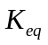 | 1.4 | Chassagnole et al. 2002
Rpi | 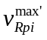 | 8.579 [μmol/gDCW.s] ^{*2} | Chassagnole et al. 2002
 |  | 4.0 | Chassagnole et al. 2002
TktA | 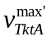 | 16.797 [μmol/gDCW.s] ^{*2} | Chassagnole et al. 2002
 |  | 1.2 | Chassagnole et al. 2002
TktB | 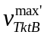 | 153.473 [μmol/gDCW.s] ^{*2} | Chassagnole et al. 2002
 |  | 10.0 | Chassagnole et al. 2002
Tal | 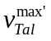 | 19.276 [μmol/gDCW.s] ^{*2} | Chassagnole et al. 2002
 |  | 1.05 | Chassagnole et al. 2002
LDH | 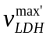 | 51.7 [μmol/gDCW.s] | *¹
 | 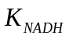 | 0.9 [μmol/gDCW] | *¹
 | 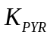 | 26.7 [μmol/gDCW] | *¹
 | 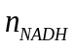 | 3 | *¹
 | 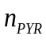 | 2 | *¹
Pfl | 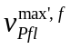 | 14.7 [μmol/gDCW.s] | *¹
 | 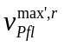 | 3.4 [μmol/gDCW.s] | *¹
 |  | 4.5 [μmol/gDCW] | *¹
 | 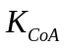 | 0.782 [μmol/gDCW] ^{*3} | Cintolesi et al. 2012
 | 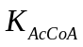 | 5.862 [μmol/gDCW] ^{*3} | Cintolesi et al. 2012
 | 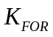 | 1.128 [g/l] ^{*3} | Cintolesi et al. 2012
ALDH | 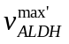 | 63.9 [μmol/gDCW.s] | *¹
 |  | 0.012 [μmol/gDCW] ^{*2} | Hoefnagel et al. 2002
 |  | 0.443 [μmol/gDCW] | *¹
 | 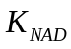 | 0.142 [μmol/gDCW] ^{*2} | Hoefnagel et al. 2002
 |  | 0.014 [μmol/gDCW] ^{*2} | Hoefnagel et al. 2002
 | 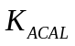 | 17.731 [μmol/gDCW] ^{*2} | Hoefnagel et al. 2002
 |  | 27.73 [μmol/gDCW] | *¹
ADH | 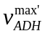 | 57.97 [μmol/gDCW.s] | *¹
 |  | 0.053 [μmol/gDCW] ^{*2} | Hoefnagel et al. 2002
 |  | 2.1 [μmol/gDCW] | *¹
 |  | 0.142 [μmol/gDCW] ^{*2} | Hoefnagel et al. 2002
 | 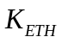 | 7.107E-04 [g/l] ^{*2, 3} | Hoefnagel et al. 2002
 |  | 2.191E+04 [μmol/gDCW] ^{*2} | Hoefnagel et al. 2002
PTACK | 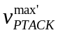 | 2.2 [μmol/gDCW.s] | *¹
 |  | 2.2E-2 [μmol/gDCW] | Kotte et al. 2010
 |  | 2.2E-2 [μmol/gDCW] | Kotte et al. 2010
 |  | 6.39E+5 | Kotte et al. 2010
 |  | 2 | Kotte et al. 2010
Acs | 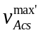 | 0.729 [μmol/gDCW.s] | *¹
 | 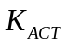 | 1.0E-3 [g/l] | Kotte et al. 2010
PDH | 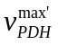 | 5.667 [μmol/gDCW.s] | *¹
 |  | 0.128 [μmol/gDCW] | Kotte et al. 2010
 | 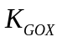 | 0.218 [μmol/gDCW] | Kotte et al. 2010
 | 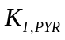 | 0.231 [μmol/gDCW] | Kotte et al. 2010
 |  | 3.4 | Kotte et al. 2010
 |  | 2.65 | Kotte et al. 2010
CS | 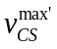 | 2.115 [μmol/gDCW.s] | *¹
 |  | 0.212 [μmol/gDCW] | Kotte et al. 2010
 | 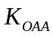 | 0.029 [μmol/gDCW] | Kotte et al. 2010
 | 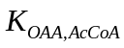 | 0.029 [μmol/gDCW] | Kotte et al. 2010
 | 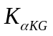 | 0.63 [μmol/gDCW] | Kotte et al., 2010
ICDH | 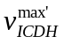 | 7.887 [μmol/gDCW.s] | *¹
 | 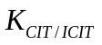 | 1.6E-4 [μmol/gDCW] | Kotte et al. 2010
 |  | 0.334 [μmol/gDCW] | Kotte et al. 2010
 |  | 127.0 | Kotte et al. 2010
 |  | 2 | Kotte et al. 2010
αKGDH | 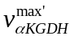 | 1.183 [μmol/gDCW.s] | *¹
 |  | 0.548 [μmol/gDCW] | Kotte et al. 2010
SDH | 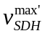 | 1.810 [μmol/gDCW.s] | *¹
 | 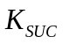 | 0.230 [μmol/gDCW] ^{*3} | Usuda et al. 2010
 | 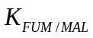 | 0.575 [μmol/gDCW] ^{*3} | Usuda et al. 2010
Frd | 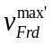 | 2.5 [μmol/gDCW.s] | *¹
 |  | 0.575 [μmol/gDCW] ^{*3} | Usuda et al. 2010
 |  | 0.230 [μmol/gDCW] ^{*3} | Usuda et al. 2010
MDH | 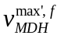 | 12.677 [μmol/gDCW.s] | *¹
 | 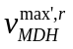 | 54.332 [μmol/gDCW.s] | *¹
 |  | 29.8 [μmol/gDCW] | *¹
 |  | 29.885 [μmol/gDCW] ^{*3} | Usuda et al. 2010
 |  | 0.563 [μmol/gDCW] | *¹
 |  | 7.012 [μmol/gDCW] ^{*3} | Usuda et al. 2010
Ppc | 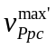 | 1.0 [μmol/gDCW.s] | *¹
 |  | 0.048 [μmol/gDCW] | Kotte et al. 2010
 |  | 0.408 [μmol/gDCW] | Kotte et al. 2010
 |  | 5.2E+6 | Kotte et al. 2010
 |  | 3 | Kotte et al. 2010
Icl | 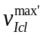 | 1.232 [μmol/gDCW.s] | *¹
 |  | 0.0022 [μmol/gDCW] | *¹
 |  | 0.055 [μmol/gDCW] | Kotte et al. 2010
 | 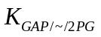 | 0.72 [μmol/gDCW] | Kotte et al. 2010
 |  | 0.827 [μmol/gDCW] | Kotte et al. 2010
 |  | 5.01 | *¹
 |  | 4 | Kotte et al. 2010
MS | 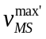 | 2.144 [μmol/gDCW.s] | *¹
 |  | 0.95 [μmol/gDCW] | Kotte et al. 2010
 |  | 0.755 [μmol/gDCW] | Kotte et al. 2010
 | 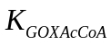 | 0.719 [μmol/gDCW] | Kotte et al. 2010
Fbp | 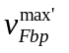 | 0.114 [μmol/gDCW.s] | *¹
 |  | 3.0E-3 [μmol/gDCW] | Kotte et al. 2010
 |  | 0.3 [μmol/gDCW] | Kotte et al. 2010
 |  | 4.0E+6 | Kotte et al. 2010
 |  | 4 | Kotte et al. 2010
Pps | 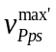 | 4.1E-3 [μmol/gDCW.s] | *¹
 |  | 1.77E-3 [μmol/gDCW] | Kotte et al. 2010
 |  | 1.0E-3 [μmol/gDCW] | Kotte et al. 2010
 |  | 1.0E-79 | Kotte et al. 2010
 |  | 2 | Kotte et al. 2010
Pck | 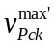 | 0.087 [μmol/gDCW.s] | *¹
 |  | 0.184 [μmol/gDCW] | Kotte et al. 2010
 |  | 1000 [μmol/gDCW] | Kotte et al. 2010
Mez | 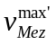 | 0.707 [μmol/gDCW.s] | *¹
 |  | 6.24E-3 [μmol/gDCW] | Kotte et al. 2010
 |  | 3.64 [μmol/gDCW] | Kotte et al. 2010
 | 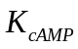 | 6.54 [μmol/gDCW] | Kotte et al. 2010
 |  | 1.04E+5 | Kotte et al. 2010
 |  | 1.33 | Kotte et al. 2010
SUC_{trans} | 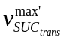 | 0.5 [μmol/gDCW.s] | *¹
 |  | 16.0 [μmol/gDCW] | *¹
Cya | 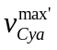 | 0.993 [μmol/gDCW.s] | Kotte et al. 2010
 | 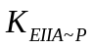 | 1.7E-3 [gProt/gDCW] | Kotte et al. 2010
cAMPdegr | 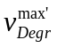 | 1.0 [μmol/gDCW.s] | *¹
 |  | 0.1 [μmol/gDCW] | Kotte et al. 2010
cAMP-Crp  association/  dissociation | 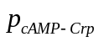 | 1.0E+8 [/s] | Kotte et al. 2010
 |  | 0.895 [μmol/gDCW] | Kotte et al. 2010
 |  | 1 | Kotte et al. 2010
Cra-FBP  association/  dissociation | 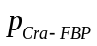 | 100 [/s] | Kotte et al. 2010
 |  | 1.36 [μmol/gDCW] | Kotte et al. 2010
 |  | 2 | Kotte et al. 2010
PdhR-PYR  association/  dissociation | 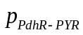 | 100 [/s] | Kotte et al. 2010
 |  | 0.164 [μmol/gDCW] | Kotte et al. 2010
 |  | 1 | Kotte et al. 2010
Nuo | 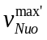 | 708.333 [μmol/gDCW.s] | *¹
 | 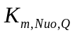 | 0.34 [μmol/gDCW] | Henkel et al. 2014
 | 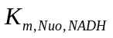 | 20 [μmol/gDCW] | Henkel et al. 2014
Ndh | 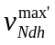 | 11.111 [μmol/gDCW.s] | *¹
 | 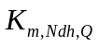 | 0.34 [μmol/gDCW] | Henkel et al. 2014
 | 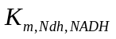 | 20 [μmol/gDCW] | Henkel et al. 2014
Cyo | 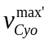 | 800.0 [μmol/gDCW.s] | *¹
 | 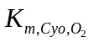 | 2E-4 [mM] | Alexeeva et al. 2002
 | 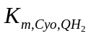 | 25.0 [μmol/gDCW] | *¹
Cyd | 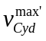 | 31.558 [μmol/gDCW.s] | *¹
 | 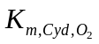 | 2.4E-5 [mM] | Alexeeva et al. 2002
 | 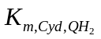 | 10.0 [μmol/gDCW] | *¹
QH₂  synthesis | 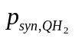 | 2.16 [μmol/gDCW] | *¹
G6P/F6P  synthesis | 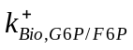 | 554.4 [-] | *¹
 | 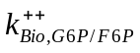 | 0.002 [/s] | *¹
GAP/DHAP  synthesis | 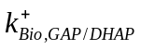 | 352.8 [-] | *¹
 | 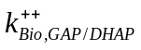 | 0.002 [/s] | *¹
PEP  synthesis | 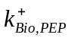 | 3.046E+3 | *¹
 | 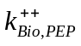 | 0.002 [/s] | *¹
PYR  synthesis | 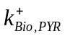 | 39.816 [-] | *¹
 | 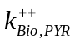 | 0.002 [/s] | *¹
AcCoA  synthesis | 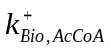 | 135.36 [-] | *¹
 | 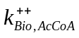 | 0.035 [/s] | *¹
R5P  synthesis | 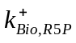 | 72.0 [-] | *¹
 | 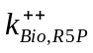 | 0.002 [/s] | *¹
E4P  synthesis | 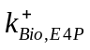 | 72.0 [-] | *¹
 | 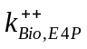 | 0.002 [/s] | *¹
αKG  synthesis | 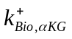 | 7.042E+3 [-] | *¹
 | 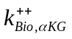 | 0.002 [/s] | *¹
OAA  synthesis | 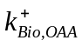 | 46.080 [-] | *¹
 | 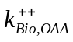 | 0.002 [/s] | *¹
cAMP-Crp | 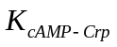 | 1.2E-3 [gProt/gDCW] | *¹
Cra | 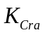 | 1.5E-2 [gProt/gDCW] | *¹
PdhR | 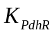 | 1.0E-3 [gProt/gDCW] | *¹
IclR | 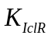 | 0.003 [gProt/gDCW] | *¹
 |  | -3 | *¹
ArcA | 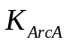 | 0.5 [μmol/gDCW] | *¹
 |  | -5 | *¹
Fnr | 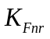 | 5.0E-6 [mM] | *¹
 |  | -5 | *¹
^{*1} The parameter values were tuned in the present model.
^{*2} The values were converted into [μmol/gDCW] using cell density 564 [gDCW/L cell volume] (Chassagnole et al. 2002).
^{*3} The values were converted into [μmol/gDCW], where the cell concentration was assumed to be a certain value (Chassagnole et al. 2002).

Table S2. Total concentrations for transcription factor and cofactor concentrations.
Concentration | Value | Reference
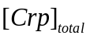 | 7.29E-3 [gProt/gDCW] | Kotte et al. 2010
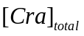 | 7.29E-3 [gProt/gDCW] | Kotte et al. 2010
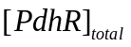 | 7.29E-3 [gProt/gDCW] | Kotte et al. 2010
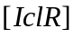 | 7.29E-3 [gProt/gDCW] | Kotte et al. 2010
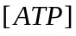 | 7.571 [μmol/gDCW] ^{*1} | Chassagnole et al. 2002
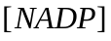 | 0.346 [μmol/gDCW] ^{*1} | Chassagnole et al. 2002
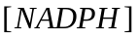 | 0.110 [μmol/gDCW] ^{*1} | Chassagnole et al. 2002
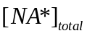 | 12.90 [μmol/gDCW] | Berrios-Rivera et al. 2002
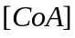 | 0.887 [μmol/gDCW] | assumed
^{*1} The values were converted into [μmol/gDCW] using cell density 564 [gDCW/L cell volume] (Chassagnole et al. 2002).

Table S3. Other parameters.
 | Value | Reference
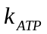 | 1E-5 [gDCW/μmol] | Matsuoka and Shimizu 2013
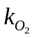 | 0.001 | assumed
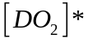 | 0.214 [mM] | -
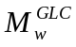 | 180.156 | -
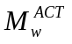 | 60.050 | -
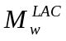 | 90.08 | -
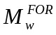 | 46.025 | -
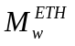 | 46.07 | -
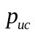 | 9.5E-7 [gDCW/μ(OD).l] | Kotte et al. 2010

References

Alexeeva S, Hellingwerf KJ, Teixeira de Mattos MJ: Quantitative assessment of oxygen availability: Perceived aerobiosis and its effect on flux distribution in the respiratory chain of Escherichia coli. J Bacteriol 2002, 184:1402-1406.

Bettenbrock K, Fischer S, Kremling A, Jahreis K, Sauter T, Gilles ED: A quantitative approach to catabolite repression in Escherichia coli. J Biol Chem 2006, 281:2578-2584.

Berrios-Rivera SJ, Bennett GN, San KY: The effect of increasing NADH availability on the redistribution of metabolic fluxes in Escherichia coli chemostat cultures. Metab Eng 2002, 4:230-237.

Chassagnole C, Noisommitt-Rizzi N, Schmid JW, Mauch K, Reuss M: Dynamic modeling of the central carbon metabolism of Escherichia coli. Biotechnol Bioeng 2002, 79:53-73.

Cintolesi A, Clomburg JM, Rigou V, Zygourakis K, Gonzalez R: Quantitative analysis of the fermentative metabolism of glycerol in Escherichia coli. Biotechnol Bioeng 2012, 109:187-198.

Henkel SG, Ter Beek A, Steinsiek S, Stagge S, Bettenbrock K, de Mattos MJT, Sauter T, Sawodny O, Ederer M: Basic regulatory principles of Escherichia coli's electron transport chain for varying oxygen conditions. PLoS ONE 2014, 9:e107640.

Hoefnagel MHN, Starrenburg MJC, Martens DE, Hugenholtz J, Kleerebezem M, Van Swam II, Bongers R, Westerhoff HV, Snoep JL: Metabolic engineering of lactic acid bacteria, the combined approach: kinetic modelling, metabolic control and experimental analysis. Microbiology 2002, 148:1003-1013.

Kotte O, Zaugg JB, Heinemann M: Bacterial adaptation through distributed sensing of metabolic fluxes. Mol Syst Biol 2010, 6:355.

Matsuoka Y, Shimizu K: Catabolite regulation analysis of Escherichia coli for acetate overflow mechanism and co-consumption of multiple sugars based on systems biology approach using computer simulation. J Biotechnol 2013, 168:155-173.

Usuda Y, Nishio Y, Iwatani S, Van Dien SJ, Imaizumi A, Shimbo K, Kageyama N, Iwahata D, Miyano H, Matsui K: Dynamic modeling of Escherichia coli metabolic and regulatory systems for amino-acid production. J Biotechnol 2010, 147:17-30.

Yao R, Hirose Y, Sarkar D, Nakahigashi K, Ye Q, Shimizu K: Catabolic regulation analysis of Escherichia coli and its crp, mlc, mgsA, pgi and ptsG mutants. Microb Cell Fact 2011, 10:67.

